Practical 1

Name:Satishkumar Rajan Nadar

Ceasar cipher:-

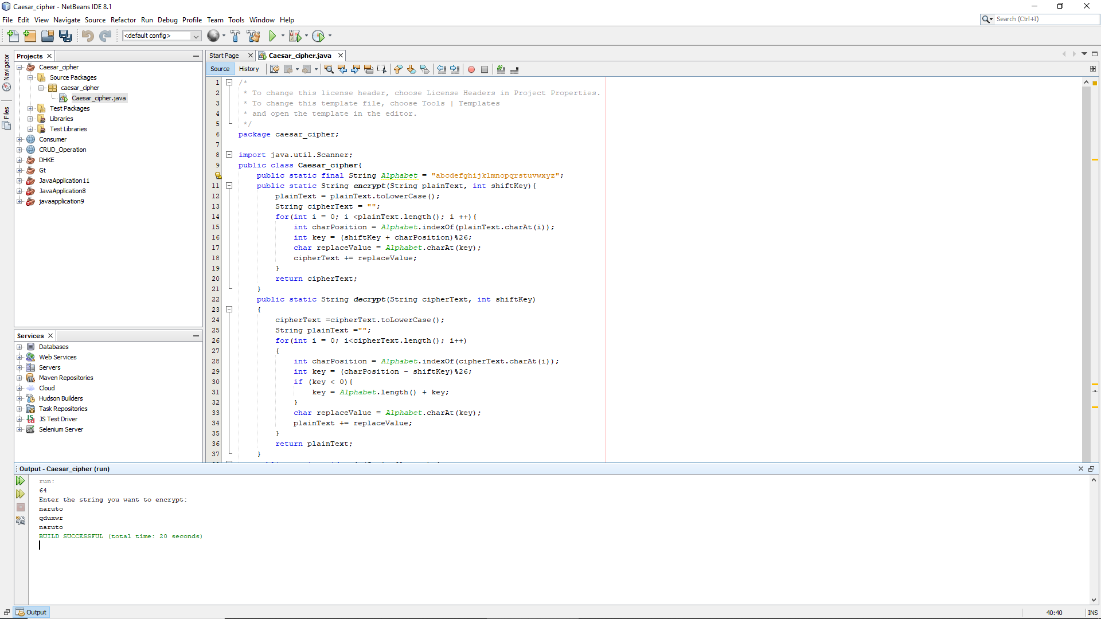

package caesar_cipher;

import java.util.Scanner;

public class Caesar_cipher{

public static final String Alphabet = "abcdefghijklmnopqrstuvwxyz";

public static String encrypt(String plainText, int shiftKey){

plainText = plainText.toLowerCase();

String cipherText = "";

for(int i = 0; i <plainText.length(); i ++){

int charPosition = Alphabet.indexOf(plainText.charAt(i));

int key = (shiftKey + charPosition)%26;

char replaceValue = Alphabet.charAt(key);

cipherText += replaceValue;

}

return cipherText;

}

public static String decrypt(String cipherText, int shiftKey)

{

cipherText =cipherText.toLowerCase();

String plainText ="";

for(int i = 0; i<cipherText.length(); i++)

{

int charPosition = Alphabet.indexOf(cipherText.charAt(i));

int key = (charPosition - shiftKey)%26;

if (key < 0){

key = Alphabet.length() + key;

}

char replaceValue = Alphabet.charAt(key);

plainText += replaceValue;

}

return plainText;

}

public static void main(String[] args) {

Scanner sc = new Scanner(System.in);

System.out.println("80");

System.out.println("Enter the string you want to encrypt:");

String message = new String();

message = sc.next();

System.out.println(encrypt(message,3));

System.out.println(decrypt(encrypt(message,3),3));

sc.close();

}

}

Monoalphabetic cipher

